## Fx xMerchant

Demo date: Jul 19, 2024  
Scoping start date: Oct 16, 2024

MSA Signature Date: Nov 7, 2024  
Onboarding Kick Off Date: Nov 21, 2024

[If Exists] Opt Out Date: May 1 2025  
Go Live Date: Jan 1, 2025

GTM POC: Ben  
Implementation POC: Ariel

ERP: QBO

Tax Integration: No Tax - but are doing a nexus study and may want advice on Tax software

### 

### Key people at Merchant

### Tim McMinn - our main POC and buyer, more on the sales ops side but in charge of process efficiency and making this all run smoothly

### Jon - Fractional Burkland CFO

### Noah - Fractional Burkland accountant

### Prayag - CEO - may have limited involvement in implementation

### 

| Notes Sections [Ops International Team to Ignore] *(AE/ Implementation to fill)*   * Info on how merchant bills   + Mostly fixed pricing with annual billing, but have a handful of monthly/quarterly customers   + May launch a PLG motion at some point in the future * Is there any important merchant relationship information?  1) Merchant temperament is generally positive. Tim (our champion) used to work with Ali at Latch so they have known each other a good amount of time 2) Tim, Jon and Noah are all very excited to put Tabs in place. Prayag (CEO) was been a hesitant buyer and insisted on an opt out 3) Streamline and automate billing and pushing data back to SFDC * We have promised AP support to be delivered operationally for this customer * There is an opt out at the 6 month mark (discussed with GS and Royce) |
| --- |

### 

Company summary  
*(AE to fill)*

heyMarvin = “a qualitative data analysis platform & research repository for user-centric teams across the globe.”

Marvin uses AI automates the tedious aspects of user research — setting up the interviews, recording the calls, taking notes, transcribing conversation, coding transcripts, elevating common themes, etc.

Marvin is now just shy of 200 customers, team is closing 1-2 deals/week , more at EoM

Goals (North star)  
*(AE/ Implementation to fill)*

What is the merchant's goal? What pain are we solving? Why are they buying Tabs?  
They have "all the pain points" that we are solving for-

* high DSO

* tons of manual work (manual process)

* delays in invoicing

* Renewals are really starting to pick up a lot and include expansions and upgrades that are not tracked well

*AP Portal support was promised and included in their contract

Is there an opt out clause? If so, what is the merchant looking for so they do not exercise it?  
Opt out at the 6 month mark (May 1)

### Billing model *(AE/ Implementation to fill)*

* Are there unique things about the customer creation process for this merchant?

Mostly fixed pricing with annual billing, but have a handful of monthly/quarterly customers

May launch a PLG motion at some point in the future

* Information on how merchant bills
* How contract is broken up
* One off things to know about the merchant

### Contract Processing Steps *(Implementation/Success to fill)*

Steps to process

Note: if you are creating a new customer please include the **billing email** as the main email address

**Note: Sometimes contracts will come into contract-ingest. If so, please refer to the body of the email, as there might be important context about price/service term in the email if not found in the contract.**

**If the contract looks like the screenshot below, follow the steps outlined below screenshot (VIEW LOOM WALKTHROUGH VIDEO HERE: https://www.loom.com/share/cb165a9dd931423fbbf124bcede03a9a?sid=da8e5f6b-ebc4-4aef-9d22-6cce0866beb2)**

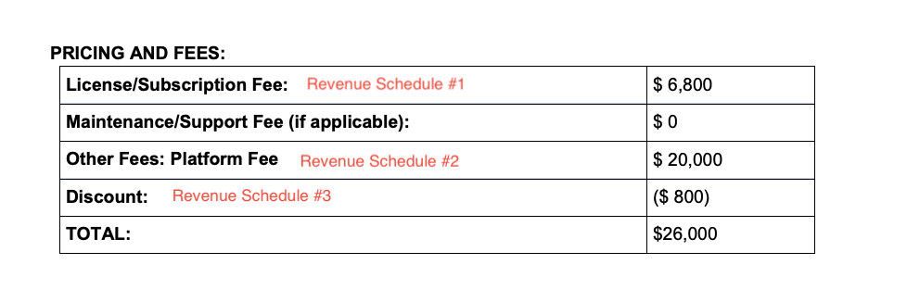

1. For the example above, you are going to create 3 different revenue schedules
   1. Revenue schedule #1
      1. Service Start Date:Latest signature date found in contract
      2. Total Months of Service: Listed under “term” in the contract”
      3. Item Name: Services
      4. Item Description: License/Subscription (or the naming convention that shows there)
      5. Integration Item: Platform Fee
      6. Total Price : Total price will be to the right (example: $6,800)
      7. Start Date: Same as service start Date
      8. Periods: 1
      9. Frequency: 1 year
      10. Net terms: Net30 unless otherwise states
          1. Please see screenshot (below)
   2. Revenue Schedule #2
      1. Service Start Date: Latest signature date found in contract
      2. Total Months of Service: Listed under “term” in the contract”
      3. Item Name: Services
      4. Item Description: Other Fees: Platform Fee
      5. Integration Item: Platform Fee
      6. Total Price: To the right, example for this: $20,000
      7. Start Date: Same as service start date
      8. Periods: 1
      9. Frequency: 1
      10. Net terms: Net30
      11. 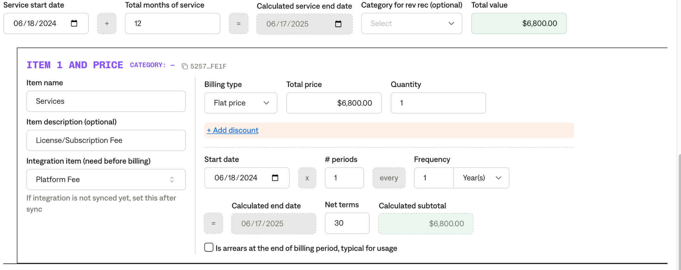
   3. Revenue schedule #3 (check screenshot under #1)
      1. Service Start Date:Latest signature date found in contract
      2. Total Months of Service: Listed under “term” in the contract”
      3. Item Name: Discount
      4. Item Description: Leave blank
      5. Integration Item: Discount
      6. ADD DISCOUNT
         1. Discount amount: put listed discount among found in contract, example $800
      7. Start Date: Same as service start date
      8. Periods: 1
      9. Frequency: 1
      10. Net terms: Net30

**When a contract looks like this (screenshot below), please follow the steps outlined below. Notes added on screenshot to help guide you to information.**

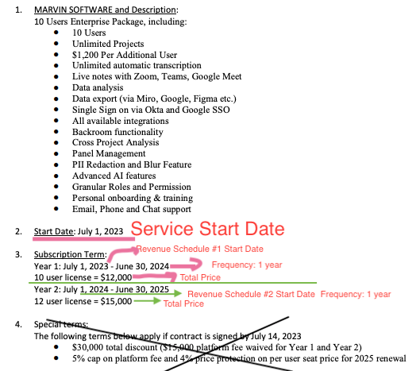

1. You will make different revenue schedules for each different pricing you see under “Subscription term”. Please see the different revenue schedules created below
   1. Refer to “subscription term”
      1. Revenue Schedule #1 (outlined in screenshot above in pink)
         1. Item Name: Subscription Fee
         2. Item Description: 10 User License (or whichever amount license is associated on the contract, refer to contract for number of licenses)
         3. Integration Item: Platform Fee
         4. Total Price: Refer to contract, example $12,000
         5. Quantity: Same as number of user licenses
         6. Start Date: Refer to contract listed in subscription term
         7. Period: ONE
         8. Frequency: 1 year
         9. Net Terms: Refer to contract under “ Fees and Invoice Timing”
      2. Revenue schedule # 2 (outlined in screenshot above in green)
         1. Item Name: Subscription Fee
         2. Item Description: 12 User License (or whichever amount license is associated on the contract, refer to contract for number of licenses)
         3. Integration item: Platform Fee
         4. Total Price: Refer to contract, example $15,000
         5. Quantity: Same as number of user licenses
         6. Start Date: Start Date Listed Under Year 2
         7. Period :ONE
         8. Frequency: 1 year
         9. Net Terms: Refer to contract under “ Fees and Invoice Timing”
      3. Repeat steps above if there is a 3rd year

Receipt instructions (only need to process the **receipt** and can mark the matching **invoice** as processed no BTs):

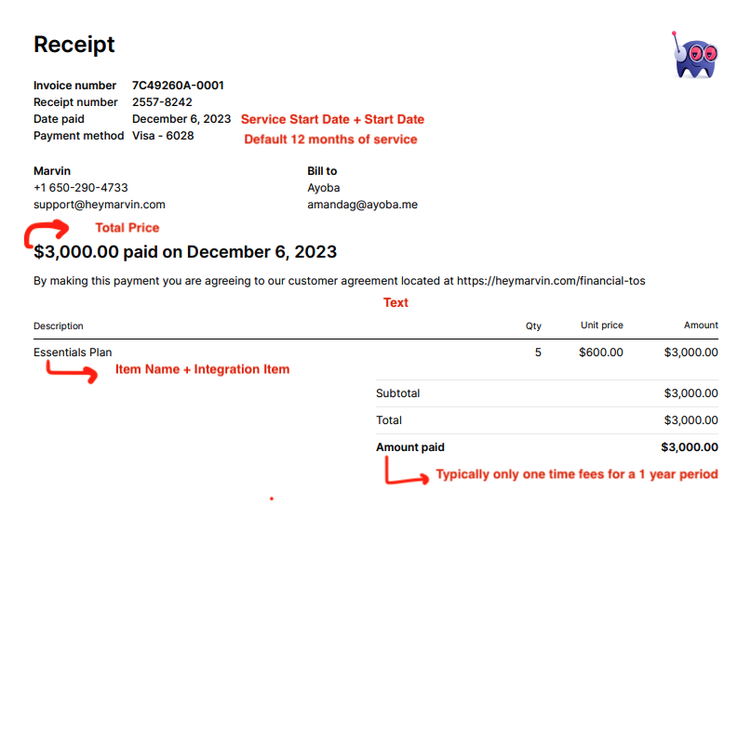

* For net payment terms, reference the corresponding invoice and take the difference between issued date and due date
  + Every receipt will have an invoice

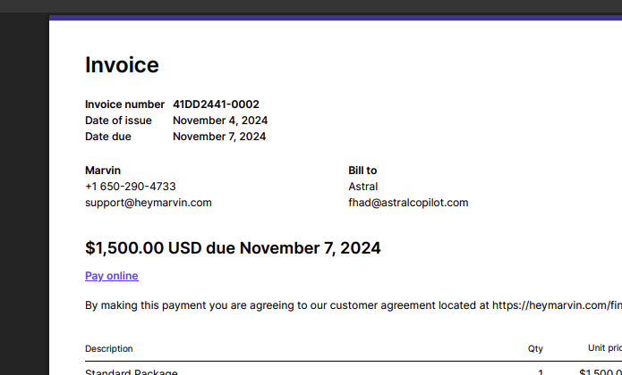

* Frequency can be None

1. Anything to ignore in contracts?
2. Specifics processing things the merchant has requested that may differ by contract (e.g. always back-date invoice date to final day of the month)
3. Default Service Term
   1. Default is 1 Year
4. Default Net Payment Terms
   1. Default 30
5. Default Billing Frequency
   1. Default 1 year
6. How do we handle taxes as a line item?
   1. If None Listed, Ops Default is every tax line item becomes a BT

### Events Processing (if necessary) *(Implementation/Success to fill)*

* Any important information on events billing

Integration Items Processing (if necessary)  
*(Implementation/Success to fill)*

* What are the instructions for assigning integration items?
* Example: All Statsig integrations items should be labeled as “Sales”
* Example: All “Pinata” integration items should be labeled as “Software Subscription Bundle” unless otherwise noted by Merchant

Post Processing Communications (if necessary)  
*(Implementation/Success to fill)*

* Does the Ops Team need to notify anyone on the team re: completion of processing batches in Implementation or Active phase?
* Who needs to be notified and when?
  + Example:
    - Who: Customer Success [Azmat Aziz] needs to be notified
    - Where: Messari internal merchant channel
    - When: contracts are processed [Merchant Phase: Active]

### Customer Information *(Implementation/Success to fill)*

* Any important information on specifics customers of this merchant
  + Special memo’s certain invoices require
  + Invoice changes due to merchant/customer relationship

### Feature Requests *(AE/Implementation/Success to fill)*

* FR 1

SFDC requests for their CSM team-

Push marketing clause to SFDC

Subscription dates, products, etc push to SFDC

### Rewatch Calls *(AE/Implementation/Success to fill)*

* <https://tabs.rewatch.com/video/njug3i4vli816rjs-jonathan-ben-intro-to-tabs-july-16-2024>
* Scoping call w/ Royce and Ben - Covered SFDC data flow + Stripe payments flow <https://tabs.rewatch.com/video/99ty6l30o6yy38q3-marvin-tabs-july-19-2024>
* October 16 demo with whole team (recorded via Zoom directly, Passcode: vTJ43b*Q) - <https://zoom.us/rec/share/eg-jYs5ZX-xb_4AkE7hFlnqYfI9GYDt8ZzpRtbmCPifvMWhATo7CKJNFrhDjk1rW.5fLG6g7CAVU7u82r>
* <https://tabs.rewatch.com/video/r8kjqi41cda7x179-tim-ben-sync-november-4-2024>
* <https://tabs.rewatch.com/video/gbv4lq9k385iq8z4-tabs-marvin-sync-on-pricing-november-5-2024>